Woodfall Primary and Nursery School

First Aid Policy

November 2023



In Consultation with
Date Agreed | Name | Position
November 2023 | Helen Hough | Headteacher
 | 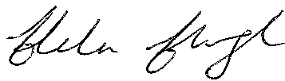
 | Duncan Haworth | Chair of Governors
Date for Review: | 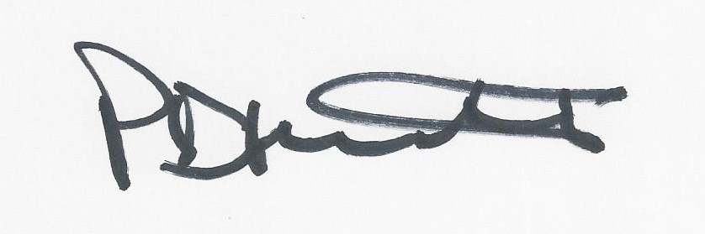
November 2024
2021

CONTENTS

Section

1.0 Policy Statement

2.0 Statement of First Aid Organisation

3.0 Arrangements for First Aid

4.0 Off-site Activities

5.0 Information on First Aid Arrangements

6.0 Accident Reporting

7.0 Pupil Accidents Involving their Head

8.0 Transport to Hospital or Home

9.0 Emergency First Aiders

1.0 Policy Statement

The Governors and Head teacher of Woodfall Primary and Nursery School accept their responsibility under the Health and Safety (First Aid) regulations 1981 and acknowledge the importance of providing First Aid for employees, children and visitors within the school.

The Governors are committed to the Authority’s procedure for reporting accidents and recognise their statutory duty to comply with the Reporting of Injuries, Diseases and Dangerous Occurrences regulations 1995. The provision of First Aid within the school will be in accordance with the Authority’s guidance on First Aid in school.

Signed (Headteacher)

Signed (Chairperson of the Governing Body)

Date 4.3.21

2.0 Statement of First Aid Organisation

The school’s arrangements for carrying out the policy include nine key principles:

- Places a duty on the Governing body to approve, implement and review the policy;
- Place individual duties on all employees;
- To report, record and where appropriate investigate all accidents;
- Records all occasions when first aid is administered to employees, pupils and visitors;
- Provide equipment and materials to carry out first aid treatment;
- Make arrangements to provide training to employees, maintain a record of that training and review annually;
- Establish a procedure for managing accidents in school which require First Aid treatment;
- Provide information to employees on the arrangements for First Aid;
- Undertake a risk assessment of the first aid requirements of the school.

3.0 Arrangements for First Aid

Materials, equipment and facilities

The school will provide materials, equipment and facilities as set out in DfEE ‘Guidance on First Aid for schools’.

- Our First Aid stations are located in the rear entrances to our Infant and Junior departments.

The location of the School Defibrillator is:

- On entry to the school office, turn right and it is located behind the door.

The contents of the kits will be checked on a regular basis by our Infant Nominated First Aiders – the list of nominated First Aiders is held centrally in our school office. Medication for named individuals should be kept within the classroom in named wallets with the child’s name and individual care plan. Specific medication (eg Epi pens) and knowledge of the location of the medication will also be checked termly by our Infant nominated First Aiders.

The list for the Appointed persons for First Aid is held centrally in our School Office along with the details, including dates, of the training undertaken to fulfil the role. The list of Paediatric First Aid appointed persons is held centrally in our School Office along with the details, including dates, of the training undertaken to fulfil the role.

Whole staff training on First Aid (4 hour course) will be undertaken every three years and all teaching and support staff will be invited to attend when necessary. The next whole school staff First Aid Training should be organised for Autumn 2026.

4.0 Off-Site Activities

At least one first aid kit will be taken on all off site activities, along with individual pupil’s medication such as inhalers, epi-pens etc.

5.0 Information on First Aid Arrangements

The Head teacher will inform all employees at the school of the following:

- the arrangements for recording and reporting accidents;
- the arrangements for First Aid;
- those employees with qualifications in First Aid;
- the location of First Aid kits.

In addition, the Headteacher will ensure that signs are displayed throughout the school providing the following information:

- names of employees with first aid qualifications;
- location of first aid boxes.

All members of staff will be made aware of the school’s First Aid Policy.

6.0 Accident Reporting

6.1 The Governing body will implement the LA’s procedures for reporting:

- all accidents to employees;
- all incidents of violence and aggression.

6.2 The Governing body is aware of its statutory duty under RIDDOR in respect of reporting the following to the Health and Safety Executive as it applies to employees:

- an accident that involves an employee being incapacitated from work for more than three consecutive days;
- an accident which requires admittance to hospital for in excess of 24 hours;
- death of an employee;
- major injury such as fracture, amputation, dislocation of shoulder, hip, knee or spine.

6.3 For non-employees and pupils an accident will only be reported under RIDDOR:

- where it is related to work being carried out by an employee or contractor and the accident results in death or major injury, or;
- it is an accident in school which requires immediate emergency treatment at hospital.

6.4 For each instance where the Headteacher considers an accident to a visitor or pupil is reportable under RIDDOR the advice of the Authority will be sought. Where a pupil has an accident it will be reported to the LA. All accidents to non-employees e.g. visitors which result in injury will be reported to the LA.

6.5 Parents/Carers should be informed when their children are subject to any accident with reportable injuries (not just head injury) and/or potentially traumatic situations while at school.

7.0 Pupil Accidents Involving Their Head

7.1 The Governing body recognise that accidents involving the pupil’s head can be problematic because the injury may not be evident and the effects only become noticeable after a period of time.

7.2 Where emergency treatment is not required, a ‘Head Bump’ letter will be sent home to the child’s parents or carers.

7.3 Head bump forms are kept in the First Aid stations located in draw files.

8.0 Transport to Hospital or Home

8.1 The Headteacher and/or Nominated First Aider will determine what is a reasonable and sensible action to take in each case.

8.2 Where the injury is an emergency an ambulance will be called following which the parent will be called.

8.3 Where hospital treatment is required but it is not an emergency, then the Headteacher will contact the parents for them to take over responsibility for the child.

8.4 If the parents cannot be contacted then the Headteacher may decide to transport the pupil to hospital.

8.5 Where the Headteacher makes arrangements for transporting a child then the following points will be observed:

- only staff cars insured to cover such transportation will be used;
- no individual member of staff should be alone with a pupil in a vehicle;
- the second member of staff will be present to provide supervision for the injured pupil.

9.0 Emergency First Aiders

All staff receive training in Emergency First Aid.

