Woodfall Primary & Nursery School

Health & Safety Policy

January 2024



In Consultation With
Date Agreed | Name | Position
25.02.2024 | Helen Hough | Headteacher
 | 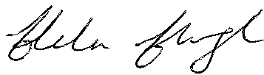
 | Duncan Haworth | Chair of Governors
 | 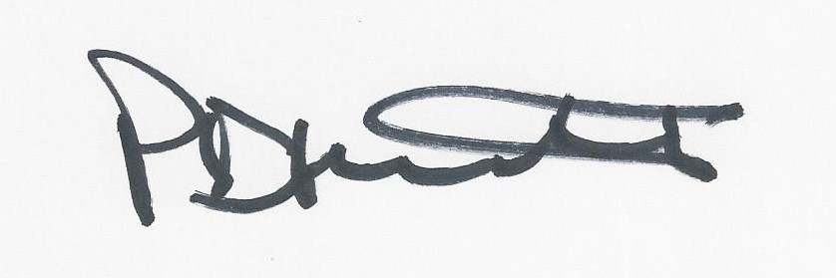
Date for Review: | January 2025

Health and Safety Policy Statement

    - Woodfall Primary and Nursery School recognises that our duty of care for the health, safety and well-being is for all people on the premises. It will take effective steps to ensure that this is achieved, so far as is reasonably practicable. In discharging this responsibility it will take into account its parallel obligations for the Health and Safety of pupils, visitors and others who might be affected by its operations.

  - The provisions in this Policy are intended to ensure that Health and Safety is
an integral part of the general process of risk management which the school operates. Thus, Health and Safety will be included in the school’s review and planning process as an issue essential to the development and maintenance of the School’s management systems.

  - The purpose of the Policy is:

- To provide the necessary authority and support for staff as they make their respective contributions to health and safety.
- To set out duties and responsibilities.
- To recognise the partnership necessary with the LA to ensure that all statutory duties in this field are met.
- To emphasise the importance of carrying out assessments of operating risks, to identify and effectively manage potential hazards through appropriate measures.

  - The Governing Body is committed to securing the health, safety and well-being of
employees, pupils and others affected by the school’s activities, including visitors and contractors. Everyone has a part to play in bringing this into effect and full co-operation is therefore expected. For employees, this is not only a matter of common sense, but also as a legal duty.

  - All employees, regardless of seniority, have a duty to take care of themselves and
others that might be affected by their acts or omissions. Staff should use equipment and working methods approved by their supervisor / senior colleague. Special care should be taken with the health and safety issues of any new venture.

2. ORGANISATION AND ARRANGEMENTS FOR IMPLEMENTING THE POLICY

2.1 The Headteacher has overall responsibility for the implementation of this Policy. To facilitate this, the Head has also designated herself as the Health and Safety Co-ordinator, with support from a designated Health and Safety Governor from the Governing Body. Each line manager will recognise and accept a personal role in ensuring that arrangements for Health and Safety are effective within his or her respective area. Collectively, the Governing Body requires Health and Safety to be taken into account in all aspects of the day to day operations of the school and will seek to encourage a positive climate in which Health and Safety can flourish.

Risk Assessment

2.2 The underlying process, which secures this Policy, is risk assessment. Assessments of potential risks will be made in conjunction with those affected and recorded in writing. It will be the responsibility of the Headteacher, Heads of Departments and line Managers to ensure that relevant risk assessments are maintained and kept up to date. Where no guidance exists on a specific topic, staff will follow the LA risk assessment process.

Areas of risk covered through assessments made in school include:

- Classrooms
- Office areas
- School Premises
- Outdoor learning
- All occupants, particularly vulnerable pupils
- Day visits
- Residential visits
- Curriculum subjects
- Fire
- PA events
- School events
- Extra-curricular activities
- Covid19

Our school is whole heartedly committed to the delivery of outdoor learning for all our children through which we teach children to identify and handle risks, and more importantly use their own initiative to solve problems and work with others.
Eg Children will learn to use tools, play, learn boundaries of behavior, both physical and social, establish and grow in confidence, self-esteem and become self-motivated.

All risk assessments for day and residential visits are uploaded to the LA ‘Evolve’ site.
All other risk assessments are filed in the Risk Assessment File held in the School Office.

Consultation

2.3 Employees with concerns should normally raise them with the Headteacher / Health and Safety Co-ordinator. However, the Governors welcome the support of trade unions in health and safety matters and staff should feel free to contact the appropriate trade union appointed safety representative. Requests for external help should be raised initially with the Headteacher / Health and Safety Co-ordinator, who will seek advice from the Departmental Health and Safety Adviser, on any concerns of employees, which cannot be resolved locally.

Contractors and School Partnerships

2.4 Contractors carrying out work for the School will be assessed on their Health and Safety record and contract performance. They will be required to act in accordance with the Construction (Design and Management) Regulations 2015 (CDM) or any other relevant current regulations, this Policy and the School’s specified local arrangements. Contractors and consultants will be required to provide risk assessments specific to the works to be undertaken. Risks are to be ‘designed out’ or minimised and appropriate method statements provided to demonstrate how any residual risks will be managed during the contract works. Contractors and consultants will be required to provide risk assessments and method statements and make appropriate arrangements with the Headteacher to ensure that the School’s Governing Body and all appropriate users are sufficiently and suitably consulted and informed on all issues relevant to risk management.

2.5 School linked partners and hirers, will exchange Health and Safety Policies and
procedures with Woodfall Primary and Nursery School and ensure that the Health and Safety of all school staff and users will be protected to a level which is reasonably practicable and equivalent in standard to the School. In particular, partners will be required to provide school staff and others who might be directly affected with sufficient guidance and advice on any risks or procedures which will be new or unusual in comparison with school’s activities.

Inspection and Monitoring

2.6 The Headteacher / Health and Safety Co-ordinator will undertake the necessary arrangements for procedures to be examined and workplaces to be inspected to ensure that precautions remain suitable and sufficient by conducting a whole school Annual Risk Assessment and Safety Review. Feedback from this process will be referred to the Governing Body.

Accident / Incident Reporting

2.7 Every incident, near miss and injury should be reported and an accident form completed. An injury that needs medical attention or involves time off work must be investigated by the person in charge of the area or activity. Where the accident falls within the LA Accident reporting criteria, the online LA Prime system - Accident Form must be completed by the relevant member of staff.

Violent / Aggressive incidents must be reported using the LA Prime system - Incident Form. The school follow the LA Violence at Work Policy.

https://www.primesafety.net/cwcc/incidents.nsf/$$ViewTemplate%20for%20IntranetUser?open&view=IntranetUserView&stay=IntranetUserView?OpenView&count=30

Training and Information

2.8 Training and development needs will be evaluated and appropriate briefing and training provided. Health and Safety training will be available to employees and records maintained by The School Business Manager. The Departmental Health and Safety Manual will be made readily available to employees with relevant notes held on the school Intranet for all employees to refer to them.

3. Policy Review

3.1 This Policy will be reviewed annually. The Governing Body will receive a summary report covering key issues, based on the Annual Risk and Safety Review.

