GROWTH MINDSET

“It is what you believe about your own intelligence that will determine how you approach a problem or a setback, and ultimately determine whether you fulfil your potential”
Carol Dweck
What Is A Growth Mindset?
A Growth Mindset is adopting the belief that ability skills can be developed by effort. To love challenges, see mistakes as intriguing and something to learn and grow from and to enjoy putting effort into learning or experiences.
The opposite of a Growth Mindset is a Fixed Mindset. This is where the belief is that you are born with a fixed amount of talent or intelligence and when faced with a challenge, are more likely to give up thinking it is too difficult.
At St Bernard’s we are teaching the children to have a Growth Mindset, which encourages them to focus on effort rather than intelligence. These skills will help them to achieve well in school and beyond.
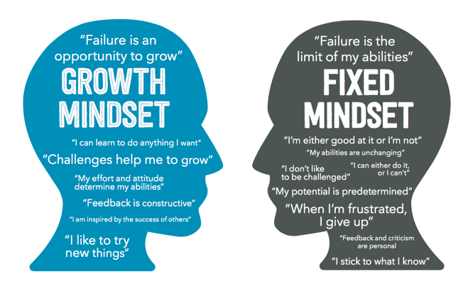
The Power Of Yet
A learner with a Fixed Mindset may make statements such as:
‘I don’t get it’ or ‘I can’t do this’
By adding the word ‘yet’ to the end of these statements, the thought process becomes more positive:
‘I don’t get it yet’, ‘I can’t do this yet’
These phrases indicate a learning curve and a pathway to solving the problem at hand. Furthermore, once pupils have made mistakes, persevered and succeeded, their confidence and self-esteem will also have improved having gone through that learning journey.

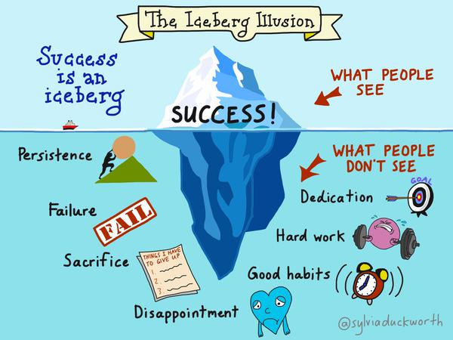

There are some great storybooks for children that support Growth Mindset teaching. We would recommend:
The Dot by Peter H. Reynolds
The Girl Who Never Made Mistakes by Mark Pett and Gary Rubinstein
Giraffes Can’t Dance by Giles Andreae

If you would like to encourage a growth mindset at home, here are 10 effective questions to ask children.
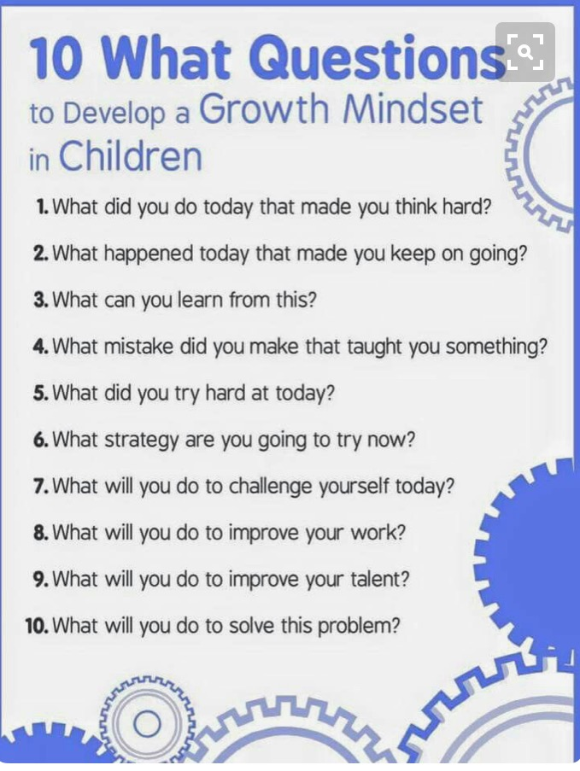

If you would like any more information please speak to a member of staff in school.

